## **Visualizing the central bank's balance sheet changes over time with the implementation of monetary policy.**

November 12, 2024

INTRODUCTION:

This report looks at how changes in interest rates affect the economy and financial stability. Normally, when interest rates go down, it becomes cheaper for businesses and people to borrow money (called expansionary monetary policy). This often leads to more spending on things like investments and purchases, which can boost the economy. It also tends to increase the value of assets like stocks and real estate. But this report goes deeper. It looks at something called "financial friction channels." These are extra factors that show how changes in interest rates affect the economy through different ways, like dealing with problems or imperfections in the financial markets.

Understanding these channels is important for policymakers because it helps them figure out how to manage interest rates effectively and keep the financial system stable. Basically, we want to figure out how much these financial factors make the effects of interest rate changes stronger, and how interest rate policies can help keep the financial system stable by looking at broader economic factors.

BACKGROUND/LITERATURE:

There has been previously a study called "Monetary Policy and Balance Sheets" by Deniz Igan and others. It is important because it focuses on the years from 1990 to 2008, which had big events like the dot-com bubble and the financial crisis. This study helps us see how changes in monetary policy affect the financial health of different parts of the economy during these tough times.

It adds to what we already know about how monetary policy works. Usually, we look at things like interest rates and asset prices. But this study also looks closely at balance sheets. These are like financial health check-ups for businesses, households, and banks. It builds on earlier research that showed how problems in financial markets can make monetary policy effective. For example, if banks are not lending enough money, cutting interest rates might not help the economy as much as we would hope.

DESCRIPTION:

Despite much research, more debate still needs to be about how important these financial friction channels are. Some studies support their significance, while others question it. We here revisit one of the original ideas about the "credit channel," which suggests that it does not replace traditional channels but amplifies their effects.

The report focuses on three critical financial friction channels:

1. **Lending Channel**: This channel examines how monetary policy changes influence the credit supply from financial intermediaries, such as banks. It explores how interest rate adjustments affect lending activity, impacting investment and consumption.

2. **Balance-Sheet Channel**: Here, the report delves into how changes in interest rates affect the financial health and behaviour of borrowers and lenders. It explores how higher interest rates can make borrowing more expensive, potentially reducing borrowing and investment, and how changes in interest rates can affect the value of assets used as collateral for loans.

3. **Risk-Taking Channel**: This channel focuses on how changes in monetary policy influence the risk-taking behaviour of financial institutions. It examines how lower interest rates can increase risk-taking as investors seek higher returns, potentially amplifying financial market volatility.

FINDINGS:

This analysis is about a central banker thinking about raising interest rates, known as tightening monetary policy. They are looking at both economic conditions (like growth and inflation) and financial stability signals (like the health of banks and markets).

They are considering increasing the repo rate and how this change affects the economy in the short term (4 quarters) and medium term (8 to 12 quarters).

When they increase interest rates, inflation goes down in both the short and medium term.

Unemployment might not change immediately due to how the economy works, but over time, it tends to rise.

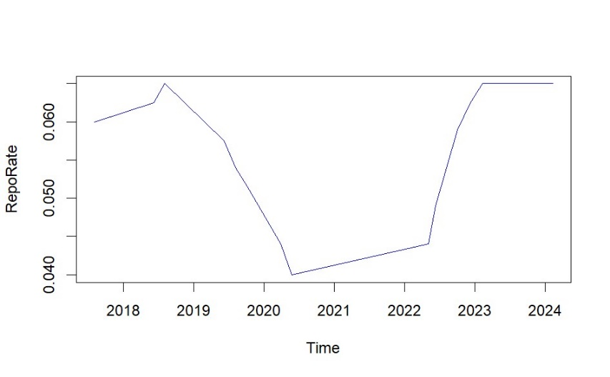

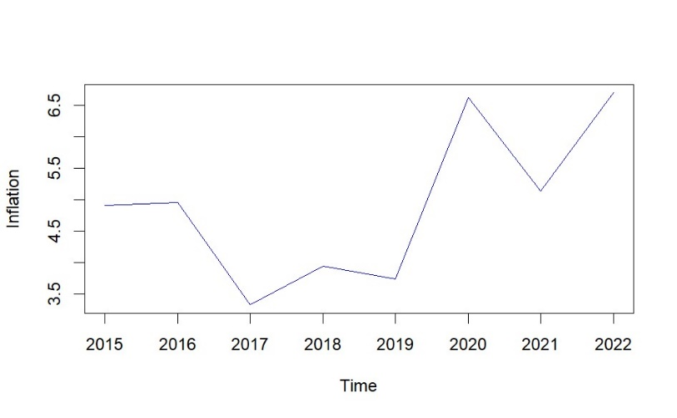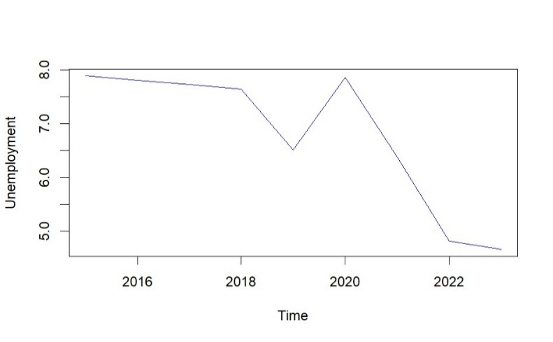

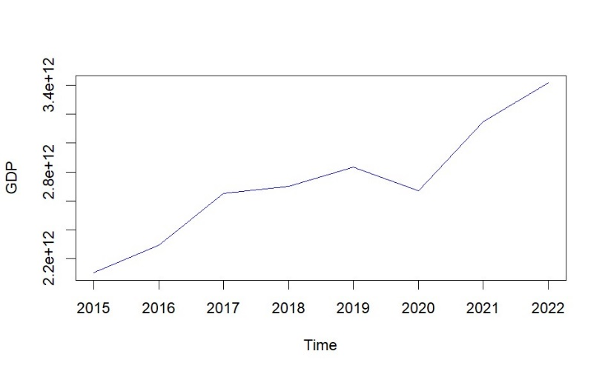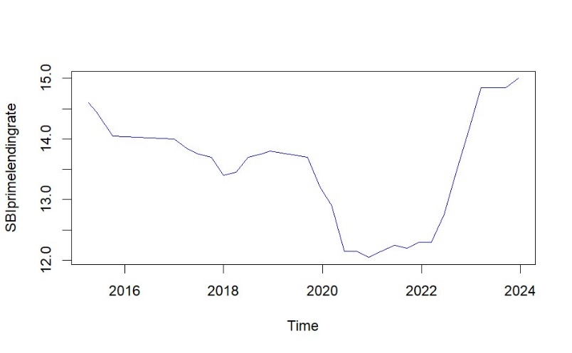

Real GDP (which measures economic growth) decreases for a while but then stabilizes.

Higher interest rates make it more expensive for banks to borrow money, so they are less likely to lend. This impacts the "lending channel" because there is less money available for loans. Also, higher rates increase the cost of borrowing for individuals and businesses, making it harder for them to pay debts and reducing the value of their assets. This is called the "balance-sheet channel," and it affects people's ability to borrow and spend. So, in simple terms, raising interest rates makes borrowing more expensive, which can slow down economic growth and affect people's ability to borrow and spend money.

When the central bank raises interest rates, banks follow suit by increasing their lending rates.

This means it becomes more expensive for people and businesses to borrow money. Initially, there might be a slight increase in total loans because existing borrowers might take out more money from their credit lines. But over time, total lending by banks decreases. This means banks are giving out fewer loans.

DISCUSSION:

How inflation, unemployment, and GDP respond to changes in monetary policy differs when we include balance-sheet variables compared to when we do not (Figure above). When we include these variables, we notice some changes:

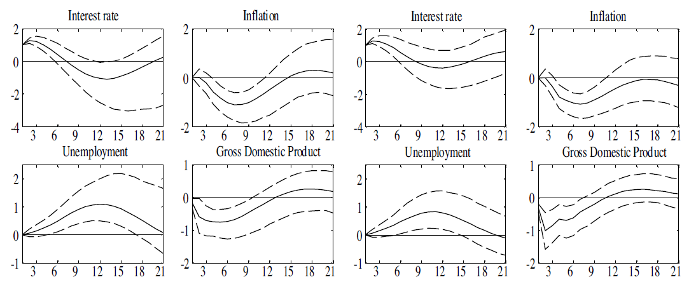

Source-<https://www.sciencedirect.com/science/article/pii/S0161893816300849>

1. Delayed Impact on Inflation: With balance-sheet variables included, inflation takes slightly longer to fall after monetary policy tightens.

2. Extended Negative Impact on Output and Unemployment: The adverse effects on output and unemployment last longer when we include balance-sheet variables.

3. Bigger Peak in Unemployment, Lower Peak in GDP: Additionally, we see that the peak in unemployment is higher, and the peak in GDP is lower.

So, including balance-sheet variables gives us a clearer picture of how monetary policy affects these economic factors, showing that inflation might take longer to respond, and the effects on output and unemployment could be more drawn out and significant.

CONCLUSION:

The analysis in this paper shows that the traditional way monetary policy affects the economy—through interest rate changes—is quite powerful. However, when we consider the effects on balance sheets (like the financial health of businesses and individuals), tightening monetary policy leads to inflation falling later and more substantially negatively impacting output and unemployment.

Ultimately, the findings suggest that to manage the economy well, it is essential to combine traditional monetary policy tools with measures dealing with financial market issues. This combined approach can help prevent any unexpected problems caused by changes in interest rates and ensure that the economy keeps growing steadily while staying financially stable.

REFERENCES:

<https://www.bankbazaar.com/home-loan/repo-rate.html>

<https://sbi.co.in/web/interest-rates/interest-rates/benchmark-prime-lending-rate-historical-data>

<https://data.worldbank.org/country/india>